 | IQVIATM Work Instruction  Global Regulatory Affairs - Translation of documents
Document Number and Revision:
CS_WI_RA0262 Revision 5
Document Owner:  Anja De Pauw | Author(s):  Veronica Glizer

PURPOSE
To describe the process for translation of documents, particularly regulatory documents.

SCOPE
  - This work instruction (WI) applies to project team staff within Global Regulatory Affairs (GRA).

  - Translations are performed by the IQVIA Translation Platform (ITP) services or third party Translation Service Providers, except for exceptional circumstances, as defined in section 6.4.

ROLES AND RESPONSIBILITIES
The following roles perform tasks described within this WI:

Role | Sections
Regulatory Project Manager (RPM) | 6.1, 6.3
Regulatory Team Member (RTM) | 6.2, 6.3, 6.4, 6.5
IQVIA GRA Translator* (IT) | 6.4
Translation Service Provider (TSP) | 6.4
IQVIA Translation Platform (ITP) | 6.4
Reviewer | 6.5
* Can be either a Certified or a Qualified Translator.

DEFINITIONS
Local language(s): The language(s) legally used in a country or the language required by the Regulatory Authority of a country.
Source language: The language in which the original document is written.
Target language: The language into which the original document is translated.
Customer language: The language in which the original document is provided by the Customer.
IQVIA GRA Certified Translator (CT): An IQVIA employee whose language capabilities are as a minimum demonstrated by possession of a certificate, diploma or university degree in a language other than their native language. A copy of the relevant certificate or diploma, or the Translator’s Curriculum Vitae which documents these academic qualifications must be filed in the IQVIA office responsible for coordinating the

Page 1 of 9
Copyright © 2014, 2016, 2018, 2020, 2021 IQVIA. All rights reserved. The contents of this document are confidential and proprietary to IQVIA Holdings, Inc. and its subsidiaries. Unauthorized use, disclosure or reproduction is strictly prohibited.

translation. The employee needs to be familiar with medical, technical (pharmaceutical) and clinical research terminology.
IQVIA GRA Qualified Translator (QT): An IQVIA employee or contractor considered by the Regional or Local (as appropriate) functional area head (e.g. Regional Head of Regulatory Affairs, Regulatory Affairs Operational Lead) to have sufficient ability in one or more languages other than the employee's native language, to translate.
Qualifications and documentation of relevant training must be filed in the IQVIA office responsible for coordinating the translation. The employee needs to be familiar with medical, technical (pharmaceutical) and clinical research terminology.
IQVIA Translation Platform (ITP): IQVIA platform that performs all tasks related to translation, including certification, using IQVIA translators.
Translation Service Provider (TSP): A professional translation organization where a Master Service Agreement is in place to perform the translation services on behalf of IQVIA. The TSPs must be routinely assessed by IQVIA Global Quality Assurance (QA) in line with Risk-based Assessment of Vendors (CS_WI_QA0205).
Marketing Authorization Application (MAA): Registration process to obtain the authorization to market a health care product in a certain country/region.

MATERIAL AND EQUIPMENT
Not Applicable

PROCEDURE

  - Staff authorized to perform Translations and Quality Control Review of Translated Documents
Only the ITP, certified or qualified Translators can perform translations and quality control review of translated documents.

No: | Who: | Step: | When:
6.1.1 | RPM or designee | Confirms if the translation can be performed either  - by the ITP (refer to the link https://quintiles.sharepoint.com/sites/Translations_at_IQVI A/SitePages/IQVIA%20Translation%20Platform.aspx to check if the project is eligible for the use of the ITP and if this platform includes the languages and type of translations required for the project).  Or, if not possible, e.g. sworn translations,  - by a TSP. In this case, verifies that the proposed TSP is qualified and/or certified (refer to the “IQVIA Vendor List” by the link MyVendor (sharepoint.com)) or contact vendorqualification@iqvia.com for support as per QG_OP_GBO0002 Vendor Management Program. | Prior to requesting any translation during the project

No: | Who: | Step: | When:
 |  | If the translation is to be performed by an IT (CT or QT) from the GRA team, the list of names of IQVIA staff members authorized to perform translations is available in their office/country. In countries with more than one official language, the list of certified/qualified Translators should also contain the information for which languages the Translator is qualified to make translations.

  - Identification of Documents Requiring Translation

No: | Who: | Step: | When:
6.2.1 | RTM | Identifies the documents to be translated for the given project. These documents could be, for example, source documents provided by the Customer or documents prepared by IQVIA’s team.  Note: Documents will be translated into:  - The local language when required by Local Regulations, e.g. labels and instructions for use, technical, clinical and legal information for MAA and related filings, as applicable.  - The Customer’s language when required by the Customer,  e.g. correspondence with Regulatory Authorities, submission forms and final approvals, Regulatory Authority Documents.  - A given language, when the scope of work requires it. | When documents are delivered to IQVIA
6.2.2 | RTM | Identifies any country or site-specific translation requirements (regular translation, translation certified by local official translator, any other) and notifies the RPM in writing, i.e. in a Word document (format can be defined as needed on the project). | When documents are delivered to RTM

  - Approval of Translation Quotations When Using the ITP or a TSP

No: | Who: | Step: | When:
6.3.1 | RTM | If the ITP will be used, sets up the access to the ITP, by following the Instructions in Appendix C. | Prior to starting any translation work with ITP
6.3.2 | RTM | Requests from ITP or TSP (as applicable) a quotation for the translation service, if required on the project, and provides it to the RPM for approval prior to proceeding, as and when required. | Prior to starting any translation work with ITP or a TSP
6.3.3 | RTM | Obtains approval from the RPM if IQVIA will be responsible for the cost of the translation. The translation quotation must have petitioner’s head or RPM’s approval (e-mail) to initiate the translation process. | Prior to initiating the translation process

No: | Who: | Step: | When:
6.3.4 | RPM or designee | Obtains approval from the Customer if the cost of the translation will be invoiced to the Customer. Email approval is acceptable. | Prior to initiating the translation process
6.3.5 | RTM | Files the approval in the appropriate folder of the Customer´s Project File (CPF), in accordance with CS_WI_RA0273 Project Management of Standalone Projects. | Once the translation quotation is approved

  - Translation of Documents
An IT (GRA) may be available to perform the translation tasks in nonstandard instances. Non-standard instances are typically defined as:
Short turnaround time to submit or respond to Regulatory Authority (RA) Translation of corrections/adjustments which are needed to minimal and non- key/non-critical portions of a document

No: | Who: | Step: | When:
6.4.1 | RTM | - Requests the translation from the ITP, TSP or IT, as applicable, and provides:  - Documents for translation,  - ITP or TSP with written instructions defining timelines and any other details regarding the translation.  - If translation is requested to ITP or a TSP:  - Documents for translation are provided through the relevant ITP or TSP platform or as applicable.  - Tracks requested translations in a Translation Status tracker (see example in Appendix B) or similar document, if applicable, and saves this tracker in the CPF. | When translation is required and,  if using the ITP or a TSP, after translation quotation is approved.
6.4.2 | ITP, TSP  or IT | Translates the document from the source language into the target language. The translated document must be clearly marked as being a translation, either in the document’s name or footer (CS_WI_RM0284 – General and Trial Master File (TMT)-Specific Document Quality - Good Documentation Practices), unless this is not required. | When document arrives for translation and within agreed timelines
6.4.3 | ITP, TSP  or IT | Checks the translation for spelling, accuracy and completeness before submitting it for quality control (QC) review. | Upon completion of the translation
6.4.4 | RTM | Saves the translated documents in the CPF. | When translation is received
6.4.5 | ITP, TSP  or IT | Translates the elements/ sections which have been amended into the target language and inserts them in the translated document. | When elements of a source language project  document are amended by the

No: | Who: | Step: | When:
 |  | Note: Appropriate version control should be applied (CS_WI_RM0284 - General and Trial Master File (TMT)-Specific Document Quality - Good Documentation Practices). | customer during the course of a project
6.4.6 | RTM | Saves the new versions of translated documents in the CPF. | Upon completion of the translation

  - Quality Control (QC) Review
To verify that the translation is complete and accurate, all translations performed by the ITP, a TSP or an IT will undergo a QC, unless otherwise requested or agreed in writing with the Customer. The review process is not a ‘word by word’ review of the translation, unless agreed with the Customer.
The Translator and Reviewer must not be the same person. The Reviewer should be an IQVIA Regulatory team member (RTM), when possible. Otherwise, the Reviewer could be a member from the TSP or the ITP.

No: | Who: | Step: | When:
6.5.1 | Reviewer | - Performs an overall check of the translated document for quality, accuracy and completeness by comparing it with the original source language document.  - Includes any identified changes/ corrections in the translated document, preferably using the track changes tool, and sends it back to the ITP, TSP or IT for amending, if required.  - Receives the updated translation from the ITP, TSP or IT and confirms it has been corrected. If not, repeats above steps.  - Documents the QC in a QC Checklist (refer to CS_TP_RA0296 Global Regulatory Affairs - QC Translations Checklist) and files it in the CPF. | Upon completion of the translation
6.5.2 | RTM | In case that the language is not available within GRA team members, the review should be performed by the ITP, a TSP, or as defined in the project.  - documents that “the review has been performed only by the ITP, TSP or other (as applicable) due to the unavailability of a GRA reviewer for that langauge. | Upon completion of the QC review
6.5.3 | RTM | - Saves the reviewed translations as well as any new updated versions in the corresponding CPF.  - Records the status of translations in the Translations Status tracker or similar document, if applicable. | Upon completion of the QC review
6.5.4 | RTM | - Sends the translated documents to the Customer | Upon completion of the QC review

- SUPPORTING DOCUMENTATION
DOCUMENT NUMBER | TITLE
ESOP References
7.1 QG_OP_GBO0002 | Vendor Management Program
7.2 CS_WI_QA0205 | Risk-based Assessment of Vendors
7.3 CS_WI_RA0273 | Global Regulatory Affairs - Project Management of Standalone Projects
7.4 CS_WI_RM0284 | General and Trial Master File (TMF)-Specific Document Quality - Good Documentation Practices
7.5 CS_TP_RA0296 | Global Regulatory Affairs - QC Translations Checklist

- SUPERSEDES
DOCUMENT NUMBER | TITLE | REVISION NUMBER
8.1 CS_WI_RA0262 | Global Regulatory Affairs - Translation of documents | 4

- MODIFICATION FROM PREVIOUS REVISION
CHANGE | SECTION REFERENCE | JUSTIFICATION
Inclusion of reference to the IQVIA Translation Platform | 2.0, 3.0, 4.0, 6.0 | Introduction of new platform to manage translations with IQVIA.
Update to Vendor Qualification links and Email | 6.1.1 (b) | New process of how vendors are qualified in IQVIA
Review step when language is not available in GRA | 6.5.2 | New step added to provide review process when language is not available in GRA team.

- APPENDICES

  - Appendix A: Translation Process

  - Appendix B: Translation Status tracker example

  - Appendix C: Instructions to obtain access to the ITP

Appendix A: Translation Process

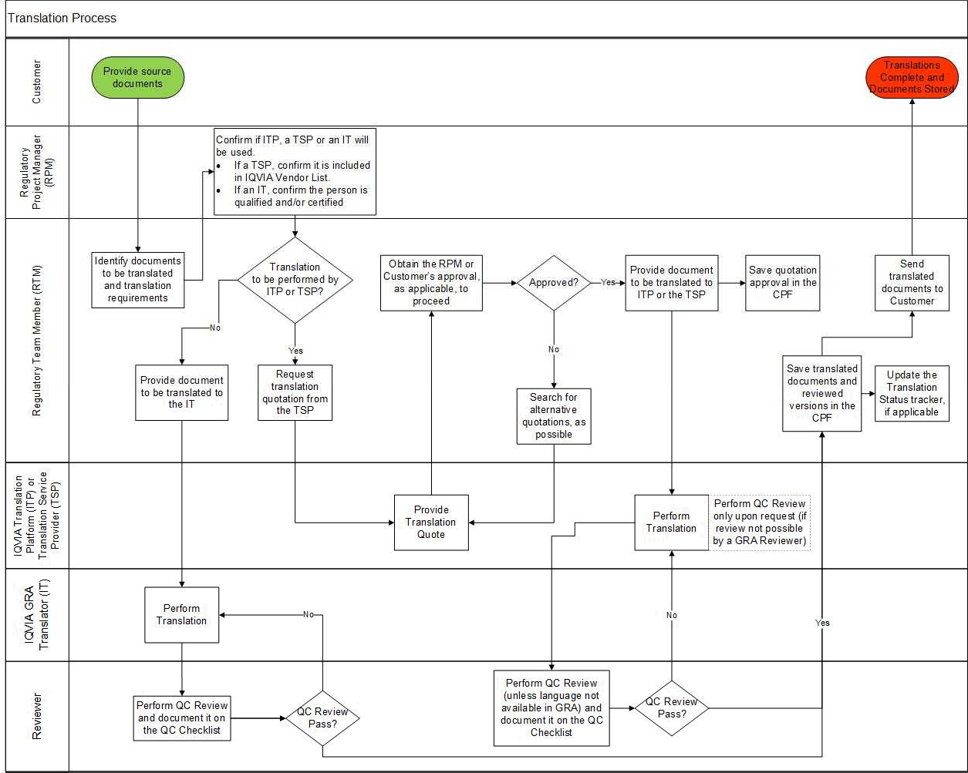

Appendix B: Translation Status tracker example

Project code:
Customer:

Source Document Name | Translation requested by | Translation requested date | Due date | Status | Translator name (TSP/ IT) | ID e-services (or as applicable according to local request system) | QC Review completed (Yes/ No) | Translation delivered to Client? (Yes/ No)

Appendix C: Instructions to obtain access to the ITP

Steps required for the use of the IQVIA™ Translation Platform if you don’t have access and not yet listed as a user:

Action |  |  | By when | Reason
1 | Update your eTraining Profile: Add the ”IQVIA Translation Services” as |  | As needed | Ensures the required training course  for ITP appears in your eTraining course list.
 | a sponsor. Choose “Requester – ITP”
 | for the profile role.
 | Complete the ITP training course in eTraining |  | As needed | Every ITP user, whether requesting or simply being informed on a translation’s status, must take the course as it is a prerequisite to access.
2 | Submit a VIA ticket to be granted |  | As needed | Users can initiate a new account request through the Access ticket in VIA. Line Manger approval of the access request ticket  is required.
 | access to IQVIA™ Platform | Translation
3 | Review available IQVIA™ Translation Platform resources |  | As needed | Resources are available on our IQVIA™ Translation Platform which also contains FAQs and more. There are QRGs Configuring your dashboard (a one-time  activity), for Creating a translation request and for Retrieving Translated  Documents. Bookmarking the site for future reference is  recommended. There is also a short presentations that provides an overview of the platform.
4 | Begin entering translation requests in IQVIA™ Translation Platform. |  | As needed | You can begin using the  ITP for all requests for only projects that were sold with IQVIA Translation Services. Use this tool to verify that a request should be entered in IQVIA Translation Platform. You can check the TaT (deadline for the translations according to their capacity per  day) per service type.

Page 9 of 9
Copyright © 2014, 2016, 2018, 2020, 2021 IQVIA. All rights reserved. The contents of this document are confidential and proprietary to IQVIA Holdings, Inc. and its subsidiaries. Unauthorized use, disclosure or reproduction is strictly prohibited.

UserName: Lewicky, Tamara (q730348) Title:
Date: Thursday, 21 October 2021, 06:20 AM Eastern Time Meaning: Signing this Document Indicates My Approval
================================================

UserName: Kemp, Jaco (q608126) Title:
Date: Thursday, 21 October 2021, 07:30 AM Eastern Time Meaning: Signing this Document Indicates My Approval
================================================

UserName: Corley, Helen (q730385) Title:
Date: Thursday, 21 October 2021, 08:57 AM Eastern Time Meaning: Signing this Document Indicates My Approval
================================================

UserName: Glizer, Veronica (q735279) Title:
Date: Thursday, 21 October 2021, 09:24 AM Eastern Time Meaning: Signing this Document Indicates My Approval
================================================

UserName: Rahman, Maggie (q1033930) Title:
Date: Thursday, 21 October 2021, 11:56 AM Eastern Time Meaning: Signing this Document Indicates My Approval
================================================

UserName: Balani, Tarun (q830700) Title:
Date: Thursday, 28 October 2021, 04:55 AM Eastern Time Meaning: Signing this Document Indicates My Approval
================================================

UserName: Lobo, Zena (q833472) Title:
Date: Thursday, 28 October 2021, 06:44 AM Eastern Time Meaning: Signing this Document Indicates My Approval
================================================

